Bliss Carman Middle School  615 Kimble Drive  Fredericton, NB  E3B 0N4  Tel: (506) 453-5401  Fax: (506) 444-4301  Principal: Chantale Cloutier  Vice-Principal: Jamie Chiasson | 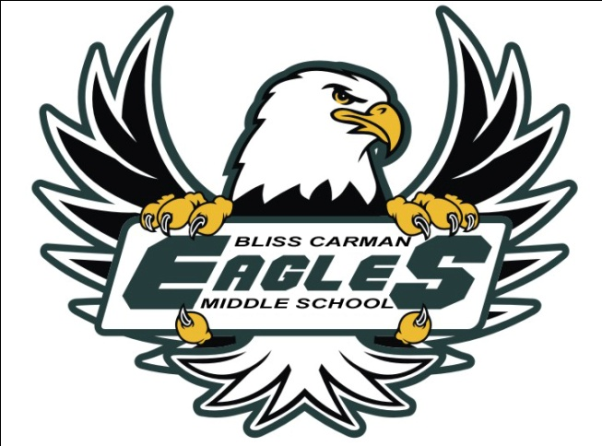
Field Trip
Activity and Location | All grade 6 students will be spending the day at Hartt Island (mini golf, park, and water park) for their year-end trip.
Route to be Taken | N/A - we will be travelling from BCMS to Hartt Island by bus (bussing cost is covered by the school.)
Dates and Times | Friday June 16th, 2017 from 8:45 a.m. -2:00 p.m.
Itinerary | Busses will be leaving BCMS at 8:45 a.m. and returning at 2:00 p.m.
Supervisor/s | Grade 6 Team Teachers
Transportation | Bus
Cost or Requirements | The cost to attend the event will be $10/student. If students wish to purchase their lunch at Hartt Island the Country Fried Food Truck will be there. Students will need to bring money to pay for food if they choose to eat there.  $7.00 combos include a juice box or water, fries, and the choice of a pogo, burger, hotdog, or chicken strips. There is also a poutine combo for $7.00. Other food will be available and vary in price.  Students should bring: a bathing suit, towel, sunscreen, snacks, lunch, drinks, and optional money.
Please cut the top portion of for your information and return the bottom portion to the school.
_________________________________________________________________________
I, __________________, give my child, _____________________ permission to
participate in the _____________ activity. I have/have not included the necessary financial contribution for this event.

________________________________ ______________________________
Parent/Guardian Signature Date

